Q.2 what type of recommendation technique is used in this research paper?
Answer: - Collaborative Filtering (CF) - Maximum Margin Matrix Factorization (MMMF)

Q.3 What dataset is used?
Answer: - 1. MovieLens 100k MovieLens 100k
2. MovieLens 1M MovieLens 1M

Q.4 theoretical understanding about the R.S. techniques?
Answer: - First… What is a Recommendation System?
A recommendation system is a computer program that tries to answer one simple question:
“What should I show to this user next?”
For example:
- Netflix → which movie?
- Amazon → which product?
- Spotify → which song?
It looks at what people liked before and tries to guess what you will like now.

Technique used in THIS paper
This paper uses:
Collaborative Filtering + Matrix Factorization + Maximum-Margin idea + Semi-supervised self-training

(1️) Collaborative Filtering (CF)

Meaning in very simple words

“People who are similar to you can help decide what you may like.”
The system does not look at movie story, genre, actor, etc.
It only looks at:
- who rated what
- and how much they rated
Example:
- You and your friend liked many same movies
- Your friend liked a new movie
The system suggests that movie to you

Visual idea
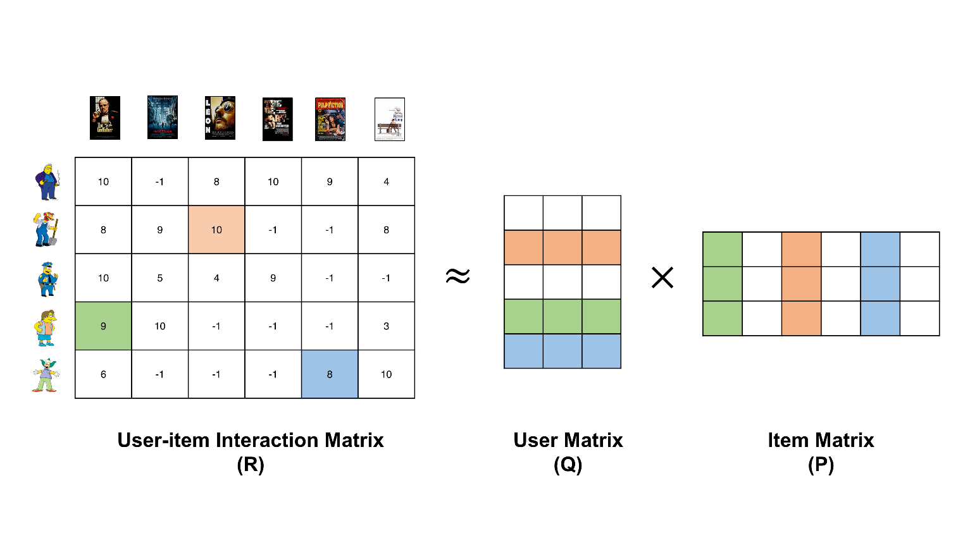
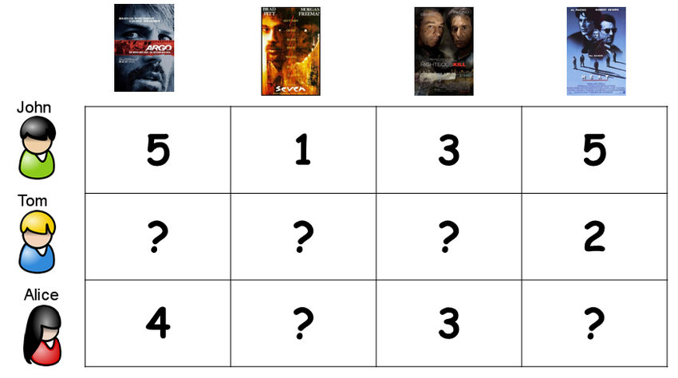
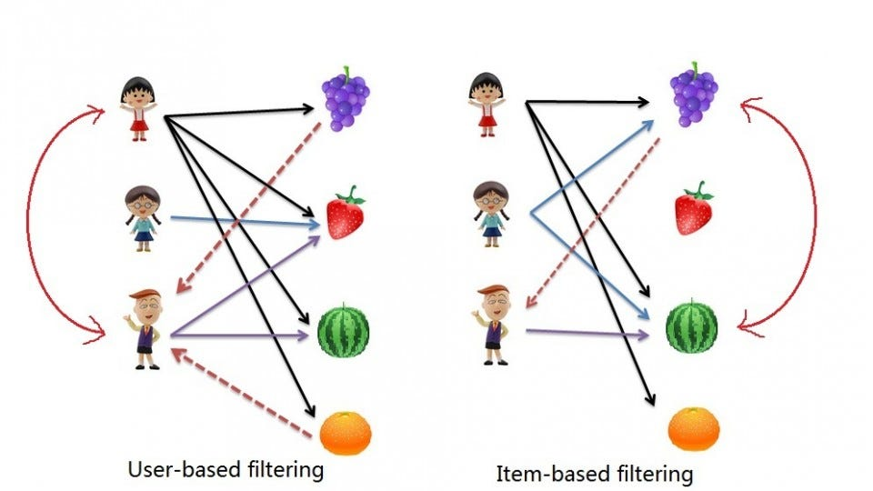
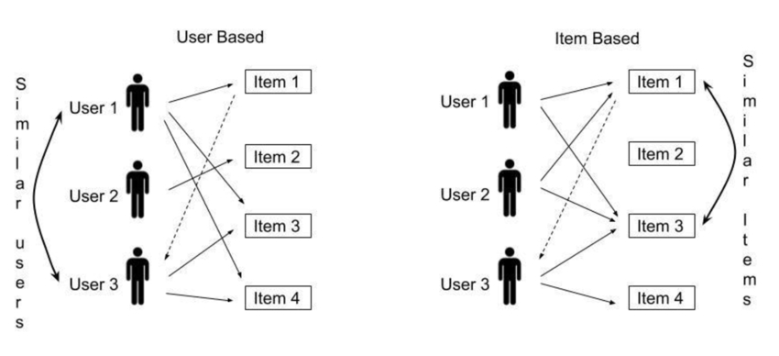

Very important point
This paper uses:
rating based collaborative filtering
Means:
Users give ratings like:
1, 2, 3, 4, 5

(2️) User–Item Rating Table (very important)
The system stores data like this:
User | Movie A | Movie B | Movie C
U1 | 5 | ? | 3
U2 | 4 | 2 | ?
U3 | ? | 5 | 4
- Number = user rated it
- ? = user never rated it
This table is called:
User–Item Rating Matrix

Big problem
Most entries are missing (lots of ?)
This problem is called:
Data sparsity
And this is exactly what these paper tries to improve.

(3) Matrix Factorization (MF)
Now comes the smart trick.
Instead of directly using the big table.
The system tries to learn:
- a small hidden vector for each user
- a small hidden vector for each item
This is called:
latent factors

Simple meaning
The system tries to discover:
- what type of user you are
- what type of movie it is
WITHOUT being told any labels.

Visual idea
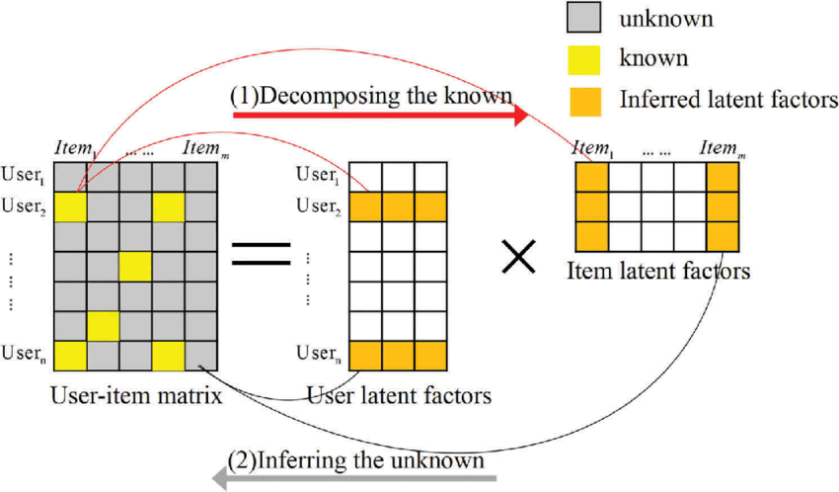
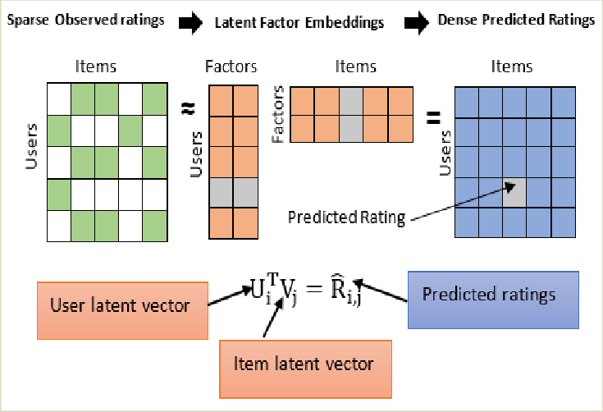
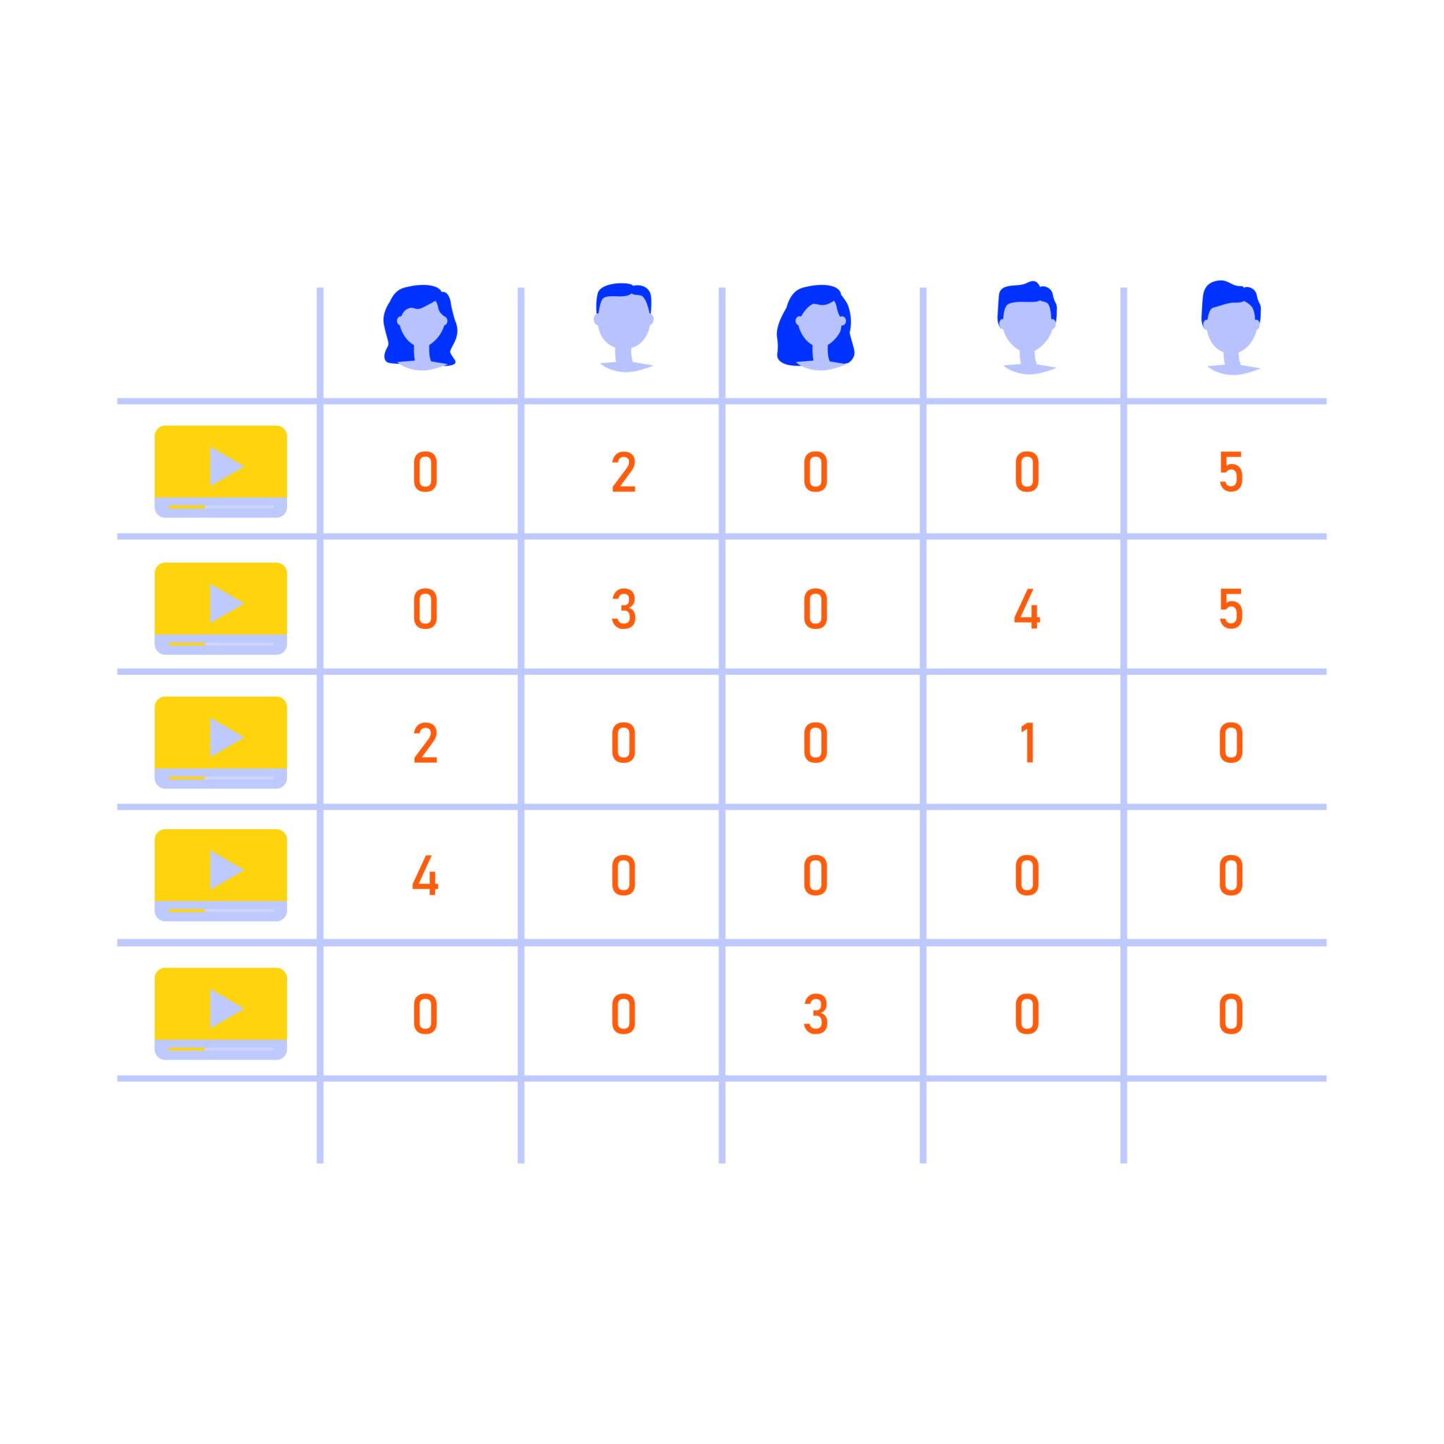
So now:
User × Item ≈ User-features × Item-features
This is the core learning technique.

(4) Maximum Margin Matrix Factorization (MMMF)
This paper does NOT use normal matrix factorization.
It uses a special one:
Maximum Margin Matrix Factorization
Let me explain what that means in very simple words.

Normal matrix factorization
Just tries to predict numbers.

MMMF adds one more idea
It tries to make predictions with a large safety gap.
This idea comes from classification (like SVM).

Simple meaning of “maximum margin”
When the system predicts a rating like:
4
It does not only say:
“maybe 4”
It tries to be:
confident that it is really 4
So, it separates ratings like:
1, 2, 3, 4, 5
with clear boundaries.

In this paper
For every user:
- the system learns
- some boundaries between ratings
Example:
boundary between rating 3 and 4
boundary between rating 4 and 5
So MMMF means:
matrix factorization + confidence-based separation between rating levels

(5) Very important: ratings are ORDERED
In this paper:
1 < 2 < 3 < 4 < 5
So, ratings are:
ordinal
This is very important.
The system knows:
Predicting 4 instead of 5 is better than predicting 1 instead of 5.
MMMF is designed for this.

(6) Semi-supervised learning
Now comes the main novelty of the paper.

What is semi-supervised learning?
We have:
- a small amount of known data (real ratings)
- a huge amount of unknown data (missing ratings)
We use both.
But how?

(7) Self-training (core idea of this paper)
This paper uses:
self-training
Which means:
The model teaches itself.

Step by step idea

Step 1
Train the model using existing ratings.

Step 2
Predict ratings for missing entries.

Step 3
Check which predictions are:
very confident

Step 4
Add those confident predictions into training data.

Step 5
Retrain again.
This is done again and again.

(8) High confidence and low confidence (very important)
Because this model is MMMF, it has boundaries.
So, the paper checks:
Where is the predicted value located?

If prediction lies in the middle of a rating region
High confidence

If prediction lies close to boundary
Low confidence
So:
- middle area → safe
- boundary area → risky

(9) Data augmentation (used in this paper)
Data augmentation here means:
adding new ratings
But only:
those predicted with high confidence
So, the matrix becomes less empty.
This is called:
rating augmentation

(10) Data refinement (also used in this paper)
Now another clever idea.
Even original ratings may be bad or noisy.
So, the paper:
removes some existing ratings that look unreliable
Which ones?
Those which fall in:
low-confidence region
This is called:
rating refinement
So, in every round:
- add confident new ratings
- remove low-confidence old ratings

Complete learning cycle used in this paper
Very simply:

① Train MMMF

② Find confident predictions

③ Add them to data

④ Remove weak ratings

⑤ Train again
This whole model is called:
ST-MMMF
(Self-Training Maximum Margin Matrix Factorization)

(11) Handling unbalanced ratings
In real datasets:
Most people give:
4 and 5
Very few give:
1
So, during augmentation:
This paper also makes sure that:
small-count ratings are not ignored
They control how many new ratings of each class are added.

(12) Dataset used in this paper
The paper uses:
- MovieLens 100K
- MovieLens 1M
Both contain:
- users
- movies
- ratings from 1 to 5

Now let me summarize everything in one clean list
This paper uses the following techniques:
Collaborative Filtering
Uses user–item ratings only.
Matrix Factorization
Learns hidden features of users and items.

Maximum Margin idea
Separates rating levels with safe gaps.

Ordinal rating modeling
Respects the order 1 < 2 < 3 < 4 < 5.

Semi-supervised learning
Uses both known and unknown ratings.

Self-training
The model adds its own confident predictions.

Data augmentation
Adds new ratings predicted with high confidence.

Data refinement
Removes low-confidence ratings.

One-line understanding (for your exam / report)
This paper uses a collaborative filtering-based maximum-margin matrix factorization model and improves it using a semi-supervised self-training approach that performs rating augmentation and refinement to reduce data sparsity.

Q.5 Mark the results?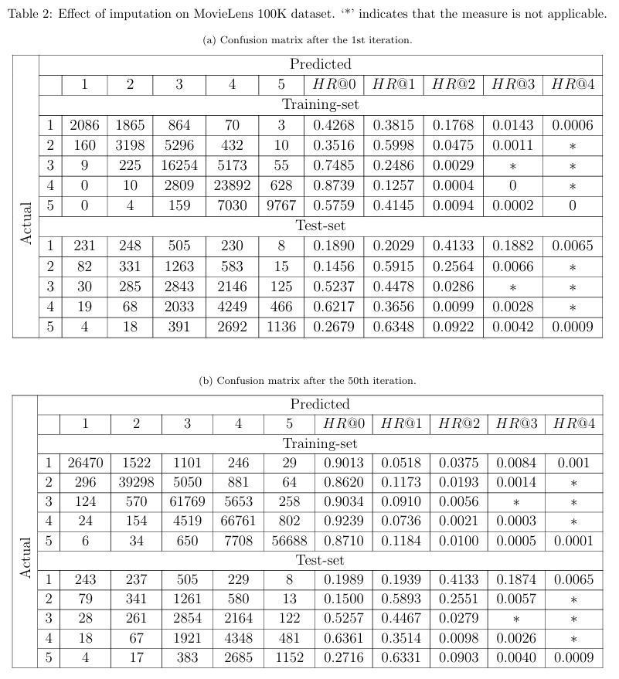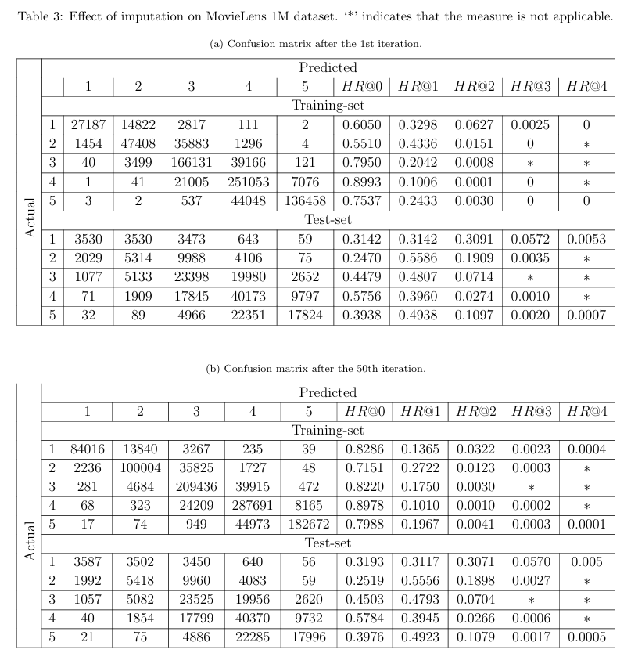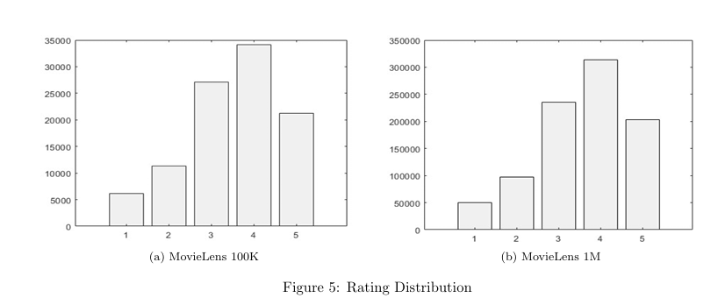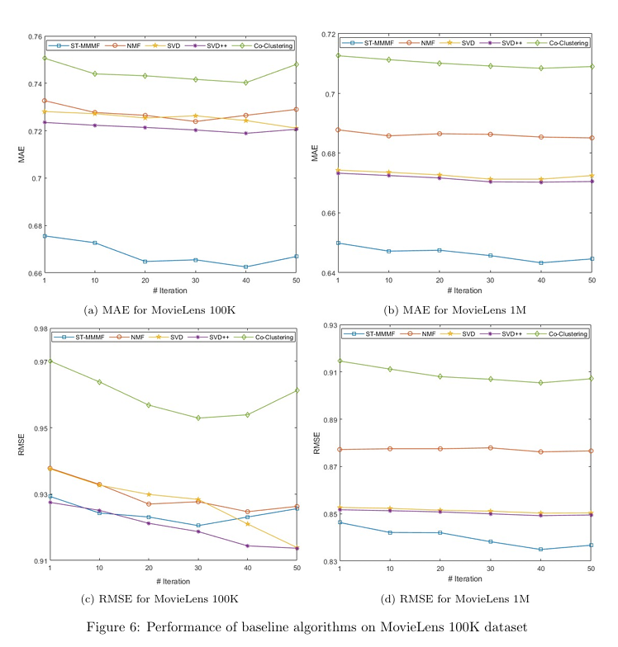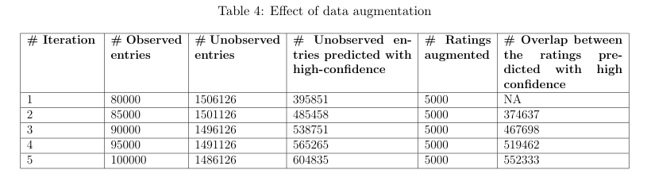
Q.6 Hyperparameters? Algorithm? Pseudocode? Block Diagram? Flowchart?
Algorithm 1: ST-MMMF (Y, d, K, λ, τ₁, τ₂)

Input: Rating Matrix: Y,
Size of Latent Dimension Space: d,
Regularization Parameter: λ,
Parameters for Rating Augmentation and Refinement: τ1 and τ2,
Sampling Percentage: s

Output: Predicted Rating Matrix: Ŷ

repeat

| Ω ← Index(Y ≠ 0)
|
| Y^{A} ← [0]^{(N×M)}
|
| U, V, Θ ← MMMF(Y, d, λ)
| /* U ∈ R^{(N×d)},V ∈ R^{(M×d)} and Θ = [θ_{ij}] ∈ R^{(N×R−1)} */
|
| X ← UV^{T}
|
| Ŷ ← Discretize (X, Θ)
|
| for i ← 1 to N do
| | ϑ_{i} ← AvgDist(θ_{i,1}, θ_{i,2},…,θ_{i,R−1})
| end
| /* Augmentation */
| foreach ij ∉ Ω do
| | for r ← 1 to R do
| | | /* θ_{i,0} ← −∞ and θ_{i,R} ← +∞ */
| | |
| | | if find 'r' satisfying Equation (12) then y^{A}_{ij} ← 'r';
| | end
| end
| /* Refinement */
| foreach ij ∈ Ω do
| | for r ← 1 to R do
| | | if find 'r' satisfying Equation (13) then y_{ij} ← 0;
| | |
| | end
| end
| Y ← Y + Sample(Y^{A}, s)
until stop criterion reached;

Equation 12: θ_{i,r−1} + ϑ_{i} ∗ τ₁ < U_{i}V^{T}_{j} < θ_{i,r} − ϑ_{i} ∗τ₁

Equation 13: θ_{i,r} − ϑ_{i} ∗ τ₂ < U_{i}V^{T}_{j} < θ_{i,r} +ϑ_{i} ∗τ₂

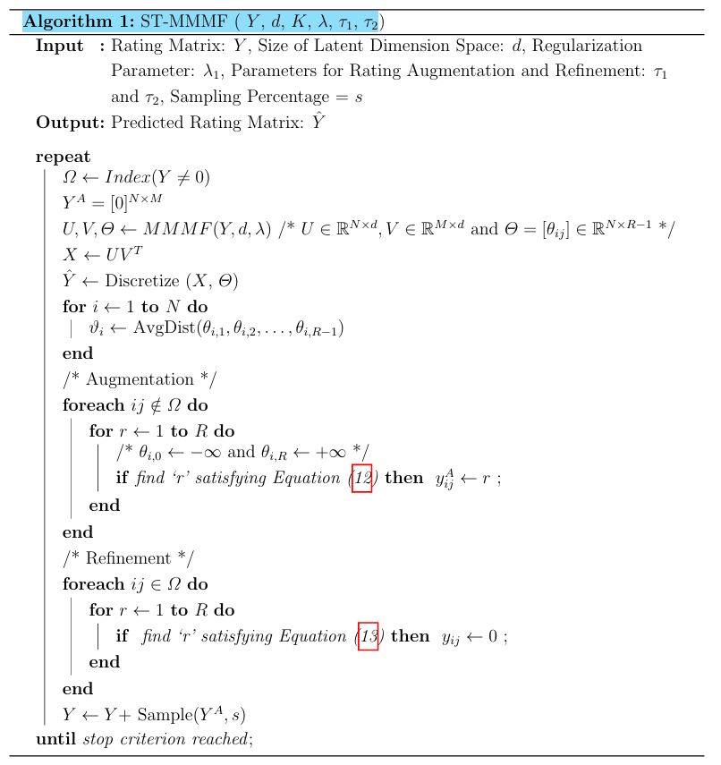

Q.7 what steps you will follow to replicate this work?
Answer: - Here is a very short and practical step-by-step plan to replicate the work of this paper.
(Only the important steps — no maths, no coding details.)

Step-1: Get the same dataset
Download:
- MovieLens 100K
- MovieLens 1M
These are the exact datasets used in the paper.

Step-2: Create the user–item rating matrix
Make a table like:
users × movies → ratings (1 to 5, missing where no rating)
This is your basic input.

Step-3: Train the base recommender model (MMMF)
Train a Maximum Margin Matrix Factorization (MMMF) model using the known ratings.
This will:
- learn user features
- learn movie features
- learn rating boundaries (for 1–5)

Step-4: Predict ratings for missing entries
Using the trained model, predict ratings for all the unknown user–movie pairs.

Step-5: Find high-confidence predictions
From those predictions:
- keep only the predictions that lie safely inside a rating region
→ these are called high-confidence predictions

Step-6: Augment the data
Add those high-confidence predicted ratings into your training data.
(This is called rating augmentation.)

Step-7: Remove low-confidence ratings
Find ratings (even original ones) that lie very close to rating boundaries and remove them.
(This is called rating refinement.)
Step-8: Repeat the process
Now repeat:
train → predict → add confident ratings → remove weak ratings
for many iterations.
This complete loop is the proposed model:
ST-MMMF

Step-9: Evaluate the result
Split data into:
- training set
- test set
Then compute:
- MAE
- RMSE
and compare with normal models like SVD, NMF, etc.

One-line replication summary
Train MMMF → use it to find confident predictions → add them to data → remove weak ratings → repeat → evaluate on MovieLens 100K and 1M.

